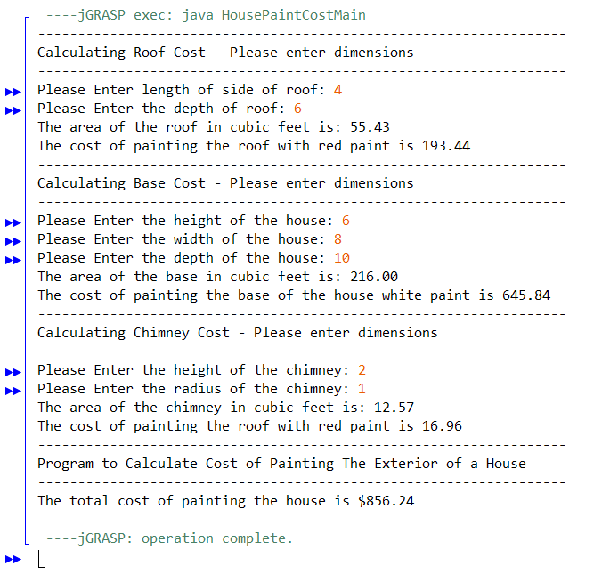
HousePaintCost main
HousePaintCost Helper
calculateWholeHousePaintCost
RoofPaintCost
Roof area and perimeter
BasePaintCost
BaseArea
ChimneyPaintCost
CalculateChimneyArea

- HousePaintCostMain
  - HousePaintCostHelper is the body code for this class and how much it’ll cost
- HousePaintCostHelper
  - Calls calculateWholeHousePaintCost in the main method
- RoofPaintCost
  - Calculate the area and perimeter of the roof
- BasePaintCost
  - Calculate the area of the base and how much it’ll cost
- ChimneyPaintCost
  - Calculate the area of the chimney and how much it’ll cost
- calculateWholeHousePaintCost
  - Use the previous methods to ask for the dimensions and calculate how much it’ll cost

